Resize this image to make it smaller

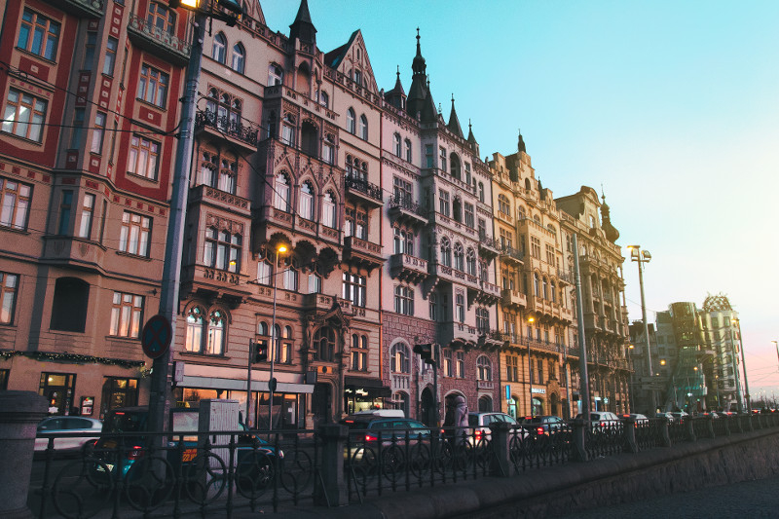
Crop the image around the house
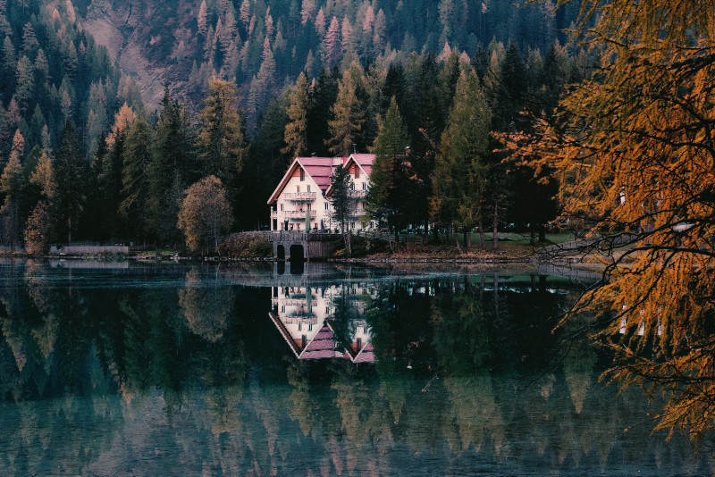

Rotate or flip this image to the normal position (the man should look to the left)

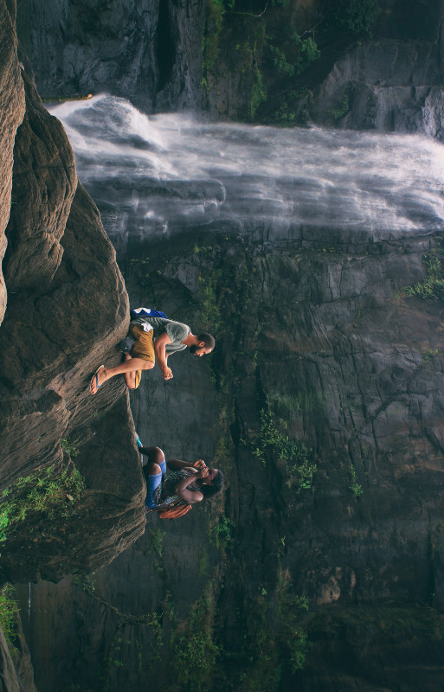
Put a thick red border around this image


